**How to choose a palm shell boiler**

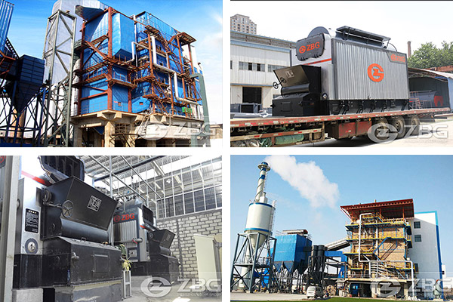

Palm shell is a kind of biomass fuel and widely used in power plants, cement plants, food factories, printing and dyeing plants, electroplating plants, etc. It is an energy-efficient and environmentally-friendly fuel. The palm shell boiler belongs to [biomass boiler](https://www.zbgboiler.com/Products/biomassboiler/)  that is specially used for biomass fuel. In addition to the palm shell, the rice husks , bagasse, straw, bark also can be used for biomass boiler. Like sugar cane baggage boiler, the application of palm shell boiler is also regional, while are more common in the tropics. The palm shell has a high calorific value and is a rare high-efficiency boiler fuel.

Here are some suggestions for you to choose palm shell boiler:If you need a palm shell boiler that less than 20 tons, you can choose a chain grate biomass boiler.Because it has the characters of The strong fuel adaptability, low original discharge concentration, no need to add bed material, discharge in the form of slag after combustion. The more important is that the operation is simple. If you need a more than 20 tons palm shell boiler , you can choose a fluidized bed biomass boiler. The maximum capacity that ZBG can develop is 280 tons.

from：<https://www.zbgboiler.com/FAQ/How-to-choose-a-palm-shell-boiler.html>